Colgate Visible White Toothpaste Saver - 200 g
from Colgate

Sale: | 156.00 FREE Delivery on orders over ₹499.00.Details
 | Inclusive of all taxes
In stock.
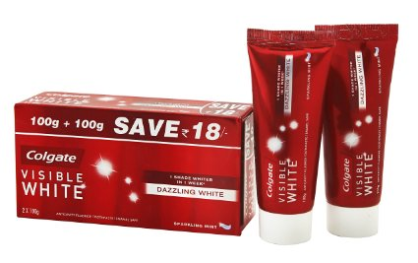
- Colgate Visible White gives you one shade whiter teeth in just one week
- Get Rs 18/- off
- Contains Whitening Accelerators
- A beauty breakthrough in oral care


The order quantity for this product is limited to 3 units per customer
Please note that orders which exceed the quantity limit will be auto-canceled. This is applicable across sellers.

Dabur Red Tooth Paste - 200 g
from DABUR

Price: | 88.00
Sale: | 79.00 FREE Delivery on orders over ₹499.00.Details
You Save: | 9.00 (10%)
 | Inclusive of all taxes
.
5 offers from 79.00

Size: 200 g

- Helps prevent toothache
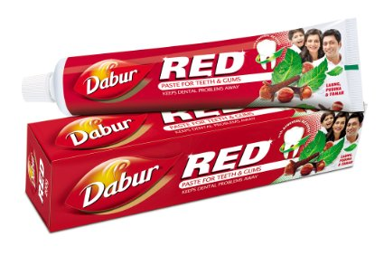
- Helps prevent bad breath
- Kills harmful germs

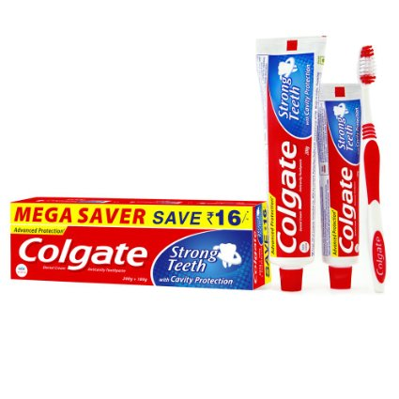

Colgate Strong Teeth Toothpaste Saver Pack - 200 g + 100 g + Toothbrush
from Colgate

Sale: | 126.00 FREE Delivery on orders over ₹499.00.Details
 | Inclusive of all taxes
In stock.
6 offers from 126.00

Size: 200 + 100 g

- No 1 Cavity Protection Toothpaste
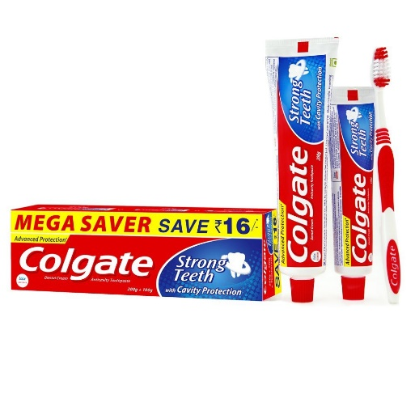
- Calcium + Minerals formula seeks and repairs early signs of cavities
- Complete all around cavity protection, germ protection, cleaner and whiter teeth, fresher breath, plaque removal, healthy gums
- Accepted by Indian Dental Association
- Colgate - No 1 brand recommended by dentists

Sensodyne Repair and Protect Toothpaste - 100 g
from Sensodyne

Sale: | 200.00 FREE Delivery on orders over ₹499.00.Details
 | Inclusive of all taxes
In stock.
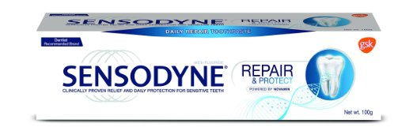
- Dentist recommended brand for sensitive teeth
- Relieves sensitivity by building a protective barrier that blocks the sensitivity caused by hot, cold, sweet and other contact triggers
- Contains fluoride to prevent cavities so that you can use it every day

Pepsodent Expert Protection Gum Care Toothpaste 35gm
from Pepsodent

Sale: | 20.00 FREE Delivery on orders over ₹499.00.
 | Inclusive of all taxes
In stock.
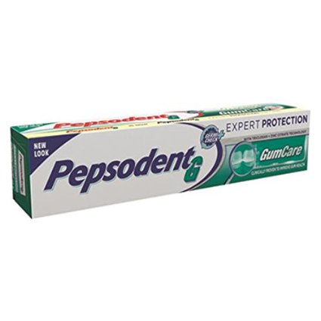
- Clinically proven to improve gum health with its triclosan + zinc citrate technology
- It strengthens gums, which are like the roots of your teeth
- Freshens breat

